Create User Personas

User personas help define the target users and their needs. Below are three sample personas for a **To-Do List App**

**Persona 1: Busy Professional**

* **Name:** Taiwo Alabi
* **Age:** 30
* **Occupation:** Project manager
* **Pain point:** Struggles to track daily tasks and deadlines efficiently.
* **Needs:**
  + Task prioritization
  + Reminders and notifications
  + Integration with calendar

**Persona 2: Student**

* **Name:** Mercy Boluwatife
* **Age:** 29
* **Occupation:** University Student
* **Pain point:** Forgets assignment and exam dates.
* **Needs:**
  + Categorization academic and personal tasks
  + Collaboration with classmate
  + Color-coded task management

**Persona 3:** Freelancer

* **Name:** Sayo Ajagbe
* **Age:** 28
* **Occupation:** Graphic Designer
* **Pain point:** Juggling multiple client project.
* **Needs:**
  + Project – based task organization
  + Deadline tracking
  + Syncing with cloud storage

**Step 2: Feature Mapping**

Now, lets map user needs into specific **features**

|  |  |
| --- | --- |
| User Needs | App Features |
| Task prioritization | High, Medium, Low priority settings |
| Reminders & Notifications | Push notifications & email alerts |
| Calendar integration | Sync with Google calendar |
| Task categorization | Tags, folders, and color coding |
| Collaboration | Shared tasks and group lists |
| Deadline tracking | Due dates and progress tracking |
| Cloud storage sync | Google Drive, Dropbox integration |

**Step 3: Wireframing the App**

Now, let’s create wireframes for the app I will generate simple wireframes from the home screen, Task Creation and Task list View

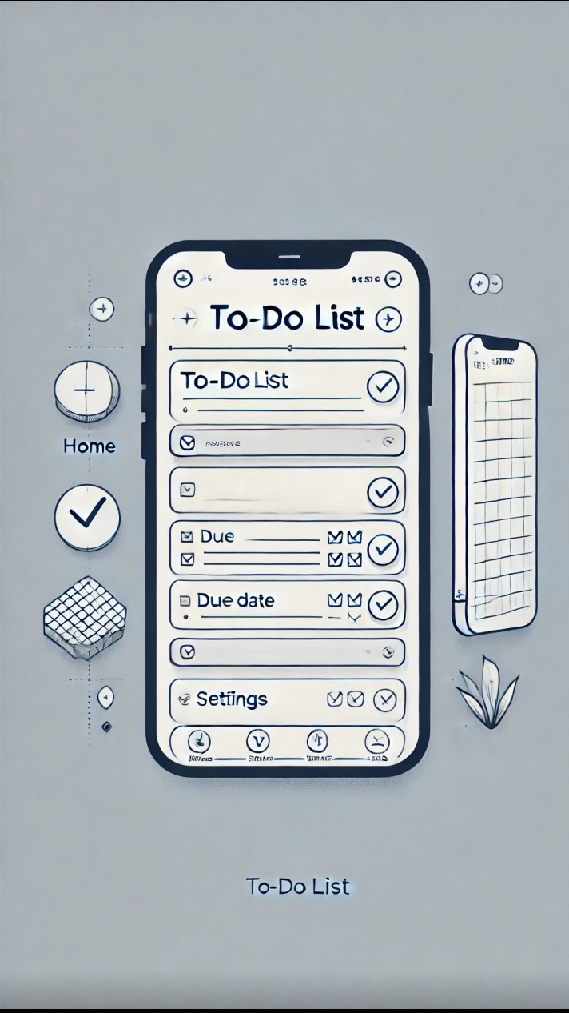

Here is a wireframe of the **To– Do List App.** It includes:

* A header with To-Do List and a plus (+) botton to add tasks.
* A task list with checkboxes, due dates, and priority tags.
* A bottom navigation bar for home calendar, and settings.